For Immediate Release
May 15, 2026

Contact:
Larry Crumbie Program Manager
Florida Trust for Historic Preservation lcrumbie@floridatrust.org
(850) 224-8128

PRESS RELEASE

Florida Trust for Historic Preservation Announces, Celebrates 2026 Florida Preservation Award Winners

St. Petersburg, Fla.– Last night, the Florida Trust for Historic Preservation recognized excellence in historic preservation throughout the state with its 2026 Florida Preservation Awards during the 2026 Preserve Florida conference in St. Petersburg on Thursday evening, May 14, 2026.
Preservation Award nominations were submitted by the public with recipients selected by a jury comprised of preservationists from all around the state.
“We are proud to recognize the outstanding achievements of the 2026 Florida Preservation Awards recipients,” said Florida Trust Board President Ennis Davis. “Their unwavering commitment to preservation inspires us all, and we extend our heartfelt congratulations to every individual and organization involved. It’s through those dedicated efforts that Florida's rich history and heritage will endure for generations.”
Here are this year’s Florida Preservation Award winners, as well as a brief description of the winning projects:

2026 Florida Preservation Awards

Legacy Award
The Legacy Award is the highest honor bestowed by the Florida Trust for Historic Preservation, designated by its Board of Trustees. It honors a person whose life exemplifies the long-term guardianship of Florida’s history and heritage through philosophy and actions.

Willard “Bill” S. Steele
Statewide

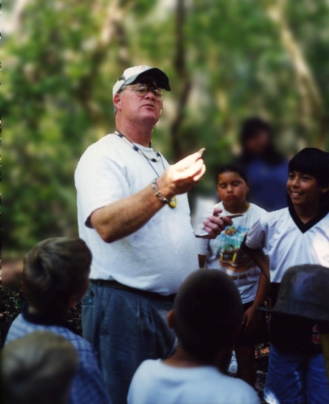
Willard “Bill” Steele has devoted his career to preserving Florida’s history, especially its Indigenous heritage. He worked with the Archaeological and Historical Conservancy and History Miami in the 1980s and 1990s, contributing to major sites including the Miami Circle, the Cutler Fossil Site, and the Okeechobee and Loxahatchee battlefields. A key turning point was his survey of the Brighton Seminole Indian Reservation, which helped establish the importance of Seminole archaeological sites and strengthen his ties with the Seminole community. Bill later served the Seminole Tribe of Florida under Billy L. Cypress, helped develop the Tribe’s first Historic Preservation Plan and became its first federally recognized Tribal Historic Preservation Officer. In that role, he helped build the office and supported the nomination of the Council Oak and Red Barn properties to the National Register.

After leaving the Tribe in 2011, Bill continued advocating for Florida’s Indigenous history, including work to identify the historic site of Miccosukee Town. His legacy is lasting and significant.

President’s Award
The President’s Award recognizes an individual’s lifelong achievements and leadership in state and national preservation arenas and service to the Florida Trust. This individual truly exemplifies working to preserve the past for the future.

Gordon “Gordie” J. Wilson
St. Augustine, St. Johns County

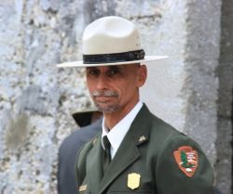
Recognized for more than 33 years of leadership at Castillo de San Marcos and Fort Matanzas National Monuments, Gordie Wilson, as superintendent, managed all aspects of park operations, including visitor services, resource protection, law enforcement and education, while fostering strong partnerships with local, state and national organizations and 25 federally recognized tribes. His collaboration with the Seminole Tribe of Florida was especially impactful, supporting the Tribe in sharing its history in its own voice. Gordie also contributed to major milestones in St. Augustine, including the 450th commemoration and international engagements, while strengthening ties with institutions like the University of Florida and FDOT. Under his leadership, volunteerism expanded, operations improved and over $20 million was secured for preservation and visitor services. His steady guidance during Hurricane Matthew and the COVID-19 pandemic further underscores his lasting legacy of stewardship, resilience and community partnership.

Historic Preservation Scholar
This award recognizes college students in Florida who have demonstrated outstanding dedication and achievement in the field of historic preservation.

Chase Panish
Tallahassee, Leon County


Flora Domitrovic
Tallahassee, Leon County
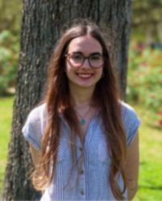
Chase Panish is an emerging preservation professional and public historian. This May, he will graduate with his MA in History, focused on Public History and Historic Preservation, from Florida State University. He has actively worked in historic preservation, both inside and outside the classroom. He nominated the Dohnányi House for the Tallahassee-Leon County Register of Historic Places. He also interned at Heritage Village in Pinellas County. Passionate about the intersection between technology and preservation, he created 3D Revit models of historic houses for the village. He also authored updates to the National Register nomination for the Union Bank in Tallahassee. For this project, he researched the local community's movement to save the bank, which underscored for him the long history and continued importance of advocacy within
preservation. Chase, a physically disabled individual, hopes to inspire others with disabilities to join the field of preservation.

Flora Domitrovic is an emerging preservation planner and historian and will graduate this May with her BA in History from Florida State University with minors in Urban and Regional Planning and Spanish, and additional graduate coursework in Geographic Information Science. She incorporates these multiple fields of study into her work in historic preservation, particularly preservation planning. Her work includes spatial analysis of transportation equity issues as an
intern at the Port Authority of New York and New Jersey, a thesis focusing on the emergence of computers in urban planning and their effect on environmental and preservation documentation,
state and national level documentation of historic structures in Tallahassee, Florida, and journalistic writing about the heritage of ceramic street signs in Valencia, Spain.

Looking forward, she seeks to pursue a master’s degree in urban planning and further work with preservation as a tool for context-engaged planning.

Individual Distinguished Service
This award honors a career dedicated to preserving Florida’s history and heritage and is intended for individuals who have clearly made an impact in their community through their efforts as a preservation activist, advocate or leader.

Daniel Ciraldo
Miami, Miami-Dade County
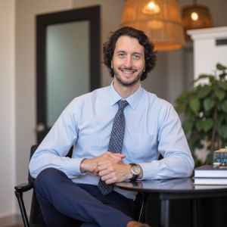
Daniel Ciraldo is a dedicated preservation leader, public educator, coalition-builder and advocate who has advanced historic preservation in Florida as a civic value tied to identity, quality of life and economic vitality. As Executive Director of the Miami Design Preservation League for eight years, he strengthened one of the state’s leading preservation organizations and helped keep preservation visible through advocacy, education, public programming and media outreach. His work in Miami Beach reflected a deep understanding of the pressures facing historic communities, and he consistently framed preservation as active public engagement rather than passive stewardship.

He also helped elevate Art Deco Weekend, including the 2024 theme “Celebrating Florida’s Historic Coastal Communities,” and concluded his tenure with the Art Deco Centennial Celebration in 2025. Beyond programming, Ciraldo has been an effective legislative advocate, working with the Florida Trust for Historic Preservation on Advocacy Days and coalition efforts against state preemption measures that threaten local preservation authority.

Kirk Davis
Titusville, Brevard County
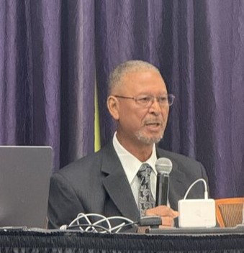
Kirk Davis has dedicated years to preserving and advocating for Titusville’s African American history. Known throughout the community as a trusted historian, Davis maintains an extensive personal archive documenting African American families, businesses and community life, including the historic Joynerville neighborhood and the once thriving South Street business district. His knowledge, relationships and commitment played a critical role in the Joynerville and Beyond Historic Preservation Initiative, helping ensure that the stories and places connected to this historic African American community, dating to the late 1800s, were documented and preserved. Davis also shares this history through public presentations, community programs and service on the City of Titusville Historic Preservation Board. He also cares for Davis Memorial Cemetery, a historic African American cemetery founded by his family in 1956. Through his research, advocacy and stewardship, Davis has become a driving force in preserving Titusville’s African American heritage.

Paul Weaver
St. Augustine, St. Johns County

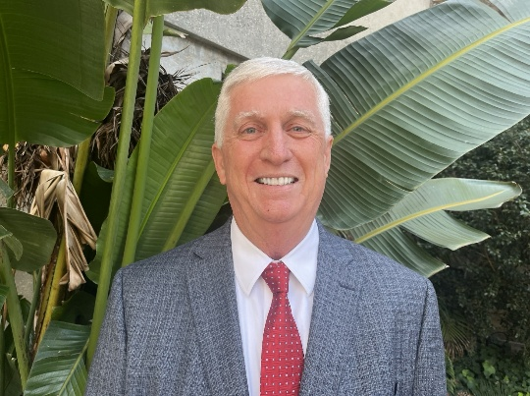
Paul Weaver has devoted nearly five decades to advancing historic preservation in St. Augustine and across Florida, leaving a profound and lasting impact on the field. Paul helped pioneer early preservation research and co-authored Florida’s first comprehensive area study evaluating historic districts through coordinated historical and architectural analysis. His company, Historic Property Associates, Inc., was an early professional preservation consulting firm in Florida, dedicated to historic research, documentation and planning. Over the course of his career, Paul has prepared numerous National Register of Historic Places nominations, securing designations and protection for many of St. Augustine’s most significant historic districts, landmarks and cultural sites. Beyond his consulting work, he has contributed as an author, preservation advocate and long-serving member of the City of St. Augustine’s Historic Architectural Review Board.

Through scholarship, leadership and lifelong dedication, Paul Weaver has played a pivotal role in documenting, protecting and promoting Florida’s irreplaceable historic heritage.

Maribel Brinkle
Tavares, Lake County

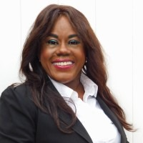
Maribel Brinkle's passion for preserving Florida's diverse histories isn't just about safeguarding artifacts — it's about igniting community spirit, fostering inclusivity and turning forgotten stories into vibrant celebrations. As President of the Apopka and Northwest Orange County Historical Society and Museum, Founder of The Museum Sharing Symposium (now connecting more than 37 museums statewide), and Director of the City of Tavares Research Center, Brinkle has spearheaded projects that blend education, art and advocacy. Three standout initiatives that exemplify her innovative approach are the Meads Bottom Mural, her collaboration on a farmworkers' program and the Magnolia Park Educational Center. These efforts not only qualify her for recognition in categories like Individual of Distinguished Service, but also showcase her fun, forward-thinking style that makes history accessible and exciting for all ages.

Volunteer of the Year
This award recognizes an individual volunteer who has made significant contributions to the preservation and promotion of Florida’s cultural heritage.

Roger Telschow
St. Augustine, St. Johns County


Roger Telschow is a dedicated advocate and volunteer for historic preservation whose efforts have had a significant impact on protecting The Polish American Society in St. Petersburg. After Hurricanes Helene and Milton caused severe damage to the historic PAS Club, Roger played a leading volunteer role repairing damages to the roof, doors, refrigerators, ceiling, terrazzo and iconic wooden dance floor. He helped coordinate volunteer-led stabilization and repairs, contributed hands-on labor and ensured all work respected the building’s historic character.

Beyond volunteer efforts with the club for the past eight years, Roger also led the process of securing professional repair services by obtaining contractor quotes and overseeing repairs. He worked full time as a volunteer to complete these repair projects. His leadership, commitment to preservation values and ability to mobilize community support make this project a model for post-disaster historic preservation and demonstrate his exceptional service.

Archaeology
This award recognizes a significant archaeological project, such as a physical site investigation, excavation and resulting report, the interpretation of a site or the creation of educational opportunities and access to the archaeological site.

People of the Apalachicola System Project
Florida Panhandle

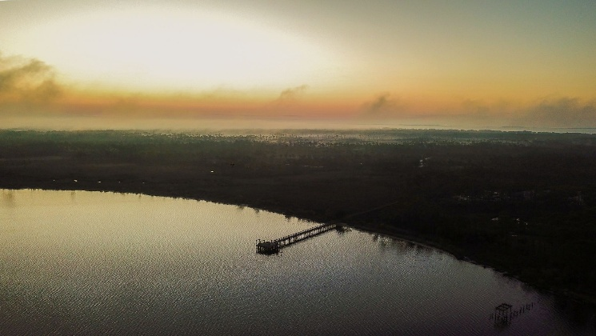
The People of the Apalachicola System project is an innovative, community-centered archaeological initiative that integrates climate science, site monitoring and public engagement to protect vulnerable cultural heritage along Florida’s northern Gulf Coast. Led by Nicole Grinnan of the University of West Florida Archaeology Institute in collaboration with the Northwest Florida Maritime Landscape Alliance for Preservation and multiple academic and agency partners, the project monitored 15 at-risk archaeological sites within the Apalachicola National Estuarine Research Reserve.

By combining repeated field documentation with Sea Levels Affecting Marshes Model projections, the team developed a forward-looking archaeological triage assessment to guide preservation priorities in the face of sea level rise. Through public workshops that prioritize community values for managing vulnerable sites like Community Conversations on Heritage at Risk, led by researchers and the Florida Public Archaeology Network, residents helped define culturally significant places and stewardship priorities, creating a proactive and replicable model for climate-informed coastal heritage preservation in Florida.

Etna Turpentine Camp: Archaeology & Public Interpretation
Brooksville, Hernando County
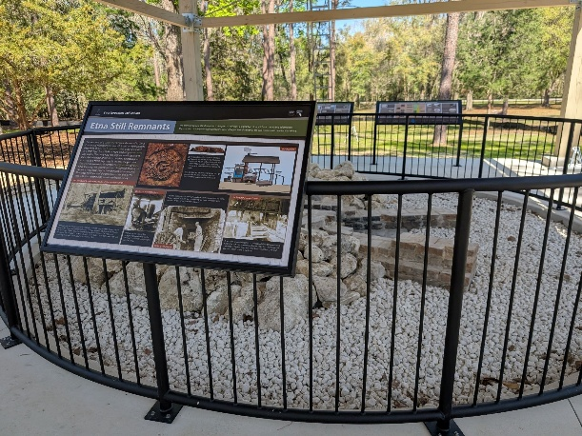
The Etna Turpentine Camp Exhibit highlights an important but often overlooked chapter of Florida’s industrial and cultural history by transforming extensive archaeological research into an accessible public resource. The historic town of Etna was a turpentine and lumber camp active from 1898 to 1926, and once home to more than 200 residents, most of whom were African American. When the Suncoast Parkway Extension intersected this National Register–listed archaeological site, Florida’s Turnpike Enterprise undertook a comprehensive effort to document, protect and interpret the resource. Through Section 106 consultation, the project resulted in a Memorandum of Agreement outlining archaeological recovery, site mitigation and the creation of a public education exhibit. The resulting installation features a relocated turpentine still firebox foundation, an interpretive pavilion and nine panels that share Etna’s history and the broader naval stores industry. The exhibit exemplifies historical accuracy, community partnership and the preservation of underrepresented histories.

Preservation Communications/Media
This award recognizes outstanding communications for heritage education programs, including books, brochures, curricula, DVDs, websites, interactive media and other publications that deal with historic preservation, archaeology or local history.

Mount Dora Historic Design Standards
Mount Dora, Lake County

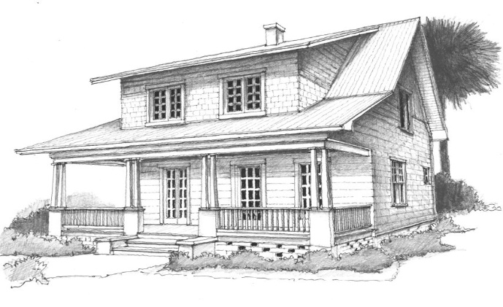
The City of Mount Dora successfully completed a grant-funded update of its Historic Preservation Standards, engaging a professional preservationist to modernize the standards guiding development within the City's historic district, which is listed on the National Register of Historic Places. The updated standards provide clear, user-friendly direction for property owners, designers, contractors and city staff when constructing, renovating or rehabilitating buildings within the historic preservation area. By translating preservation best practices into practical design guidance, the project improves transparency, consistency and predictability in the review process while protecting the architectural character that defines Mount Dora. This effort supports appropriate investment, preserves historic resources for future generations and strengthens the community's identity and heritage tourism economy. The project demonstrates how strategic grant funding and professional expertise can enhance preservation tools while balancing historic protection with thoughtful growth.

Florida Frontiers: “The Ma Barker House”
Ocala, Marion County

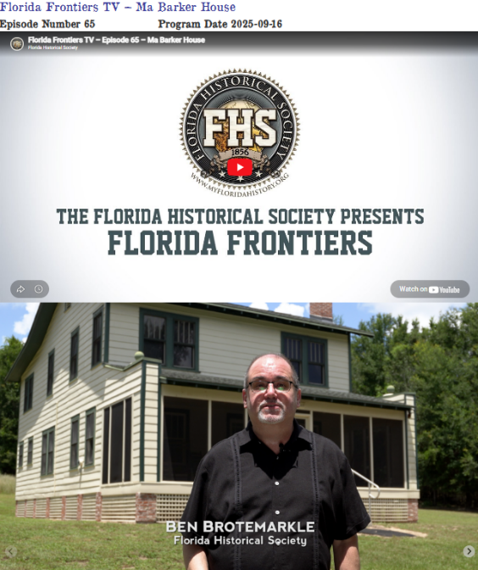
The episode of The Florida Historical Society Presents: Florida Frontiers called “The Ma Barker House” was originally broadcast in September 2025. Established in 1856, the Florida Historical Society is dedicated to preserving Florida history and culture through a variety of publications, projects, programs, events and activities that are accessible to the public. The media programs, Florida Frontiers: The Weekly Radio Magazine of the Florida Historical Society and the television series The Florida Historical Society Presents: Florida Frontiers are both effective educational outreach projects. The radio program airs on NPR stations around the state and is also available as a podcast. The television series airs on PBS affiliates throughout the state and can also be streamed from the Florida Historical Society YouTube channel. The program chronicles the historical significance of the home, its relocation to a new site, and its restoration into a museum.

Joynerville & Beyond Historic Preservation Initiative
Titusville, Brevard County

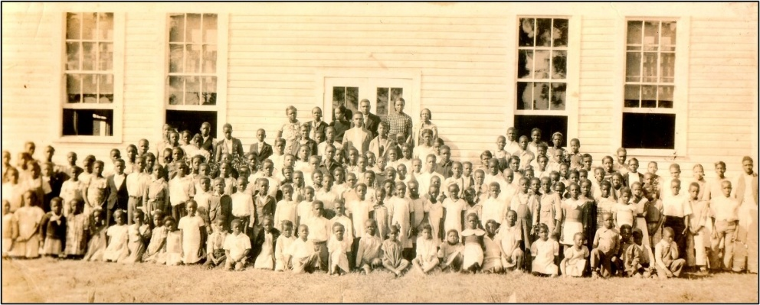
The Joynerville & Beyond Historic Preservation Initiative documents and preserves the history of Titusville’s historic African American neighborhoods and the once bustling South Street Business District. Through archival research, community engagement and oral history interviews, the project recovered stories and locations that had largely faded from the public record. Residents participated in mapping activities to identify former businesses, gathering places and landmarks while sharing photographs, documents and memories passed down through generations. Oral history interviews captured firsthand memories of life in Joynerville during the mid-twentieth century, including the Black-owned businesses that once lined South Street, the entrepreneurs and community leaders who served as pillars of the neighborhood, and the social networks that supported a thriving local economy. The initiative culminated in the publication of the Joynerville & Beyond: The African American Community of Titusville report, transforming community memory into a lasting historical record and advancing placekeeping by safeguarding the cultural, historical and social identity of Joynerville.

Modern Dwelling: Manufactured Housing Communities of Sarasota, FL
Sarasota, Sarasota County
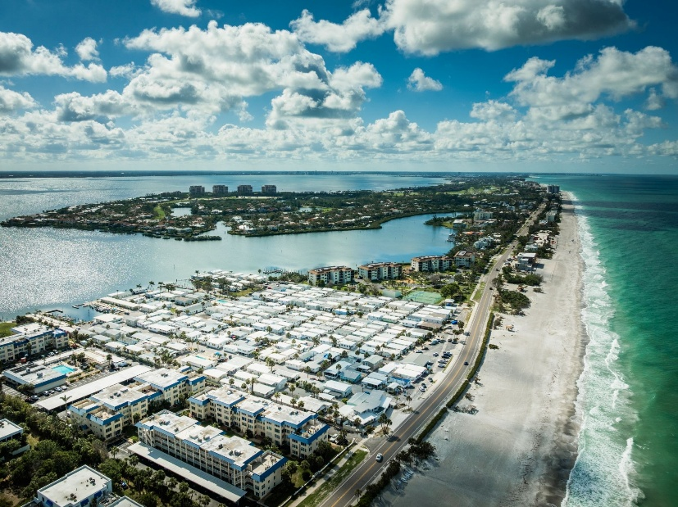
Manufactured housing, shaped over the past century from travel trailers to today’s
federally regulated homes, represents both an innovative solution to housing shortages
and a stigmatized form of dwelling often overlooked in policy and planning. A
collaboration between Architecture Sarasota and the Sarasota Alliance for Historic Preservation, the two organizations developed and employed a novel approach to placekeeping through a thematic survey of Sarasota County’s manufactured housing communities aimed at establishing a model approach that can inspire and inform similar projects in other Florida communities and across the United States.

By taking the first step toward recognizing their cultural significance, preservationists can propose treating these communities as historic districts, ensuring they are acknowledged not only for their practical value but also for their social, historical and architectural contributions.

Preserving Place

This award recognizes individuals, organizations or projects in Florida that have excelled in placemaking and placekeeping, contributing to the enhancement and revitalization of communities while respecting their unique cultural heritage.

St. Johns County Black Heritage Trail

St. Augustine, St. Johns County

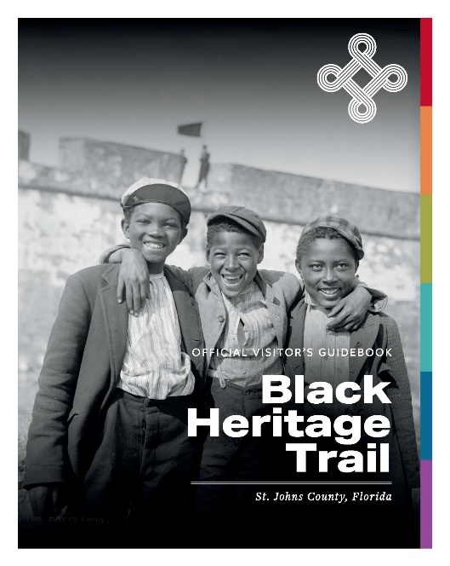
The St. Johns County Black Heritage Trail is an excellent example of preserving place. The Trail involved community collaboration that built on current preservation and storytelling efforts to showcase a unique and significant heritage of St. Johns County. The Trail brings together over 450 years of Black heritage in St. Johns County. Beginning with the Spanish in the 1500s, it is home to the first free Black community in what is now the United States and events that had a direct influence on the passage of the Civil Rights Act of 1964. It was home to a historically Black college and university and is the southern terminus of the Gullah Geechee Heritage Corridor.

The Trail guidebook presents four themes, describes 20 sites with a map and highlights 10 influential individuals. Signs were added to five sites to bring attention to their Black heritage, and a website includes the timeline, stories, map, site listings and a viewable or downloadable version of the printed guide.

Restoration, Rehabilitation or Adaptive Use
This award recognizes best practices for the restoration, rehabilitation or adaptive use of a building, complex of buildings or a district. Restoration returns a property to its appearance at a particular period of time. Rehabilitation allows for repairs, alterations and additions, while preserving those portions or features which convey its historical, cultural or architectural values. Adaptive use allows compatible new functions for a building while maintaining its character-defining features.

This category may include residential, commercial, governmental, educational and institutional projects, both for individual buildings and/or historic districts.

Opa-locka Historic City Hall
Opa-Locka, Miami-Dade County

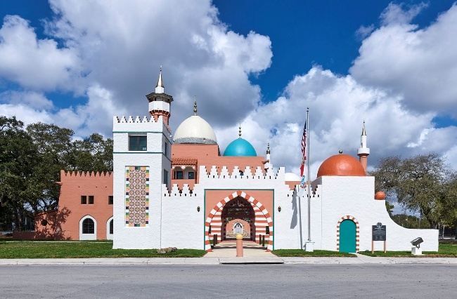
The restoration of Opa-locka Historic City Hall, one of the nation’s most distinctive examples of Moorish Revival architecture, was completed in January 2025 after more than a decade of challenges. Originally built in 1926 as the sales center for Glenn Curtiss’ Arabian Nights inspired community, the building later served as Opa-locka’s City Hall for over 70 years. After falling into severe disrepair, rehabilitation began in 2014 but was halted, leaving the structure partially restored and exposed to further damage.
In 2021, the project was included in the Florida Trust for Historic Preservation’s 11 to Save list. Guided by architect Bernhardt Muller’s original drawings and archival photographs, M.C. Harry & Associates and its engineering team completed a comprehensive rehabilitation that restored the building’s domes, minarets, arches and courtyards while upgrading structural systems and modern utilities. The project successfully revived a cherished civic landmark and reaffirmed Opa-locka’s unique cultural and architectural legacy.

Bishop House
Key West, Monroe County

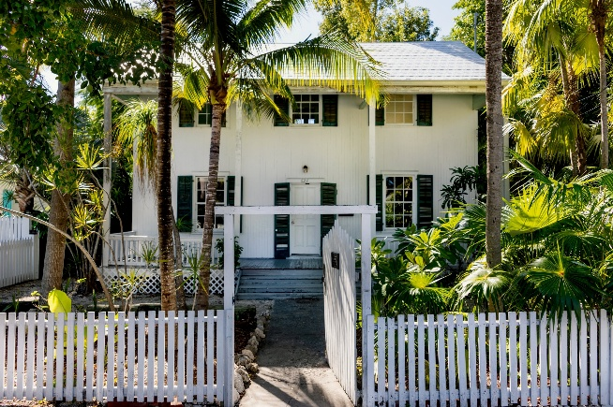
The building that stands at 624 White Street was built in 1889 and is one of a small number of surviving eyebrow houses in the Key West Historic District. From 1938 to 1946, it was the home of renowned American poet Elizabeth Bishop. The nonprofit Key West Literary Seminar has restored the house to its 1938-46 period and created a public garden inspired by Bishop’s experiences in Florida. Restoration highlights include original 19th century windows and wood louvered shutters and a cistern returned to historic use, gathering rainwater to irrigate a garden of native plants and tropical fruit trees. No detail was overlooked, with original built-in book shelves, bathtubs, sinks, faucets, light fixtures and doorknobs all restored and returned to use. Arlo Haskell led the $3.4 million capital campaign and managed the project with architect David Salay of Bender & Associates and contractor Nick Egan of Egan Built.

St. Petersburg Standard Oil Service Station
St. Petersburg, Pinellas County

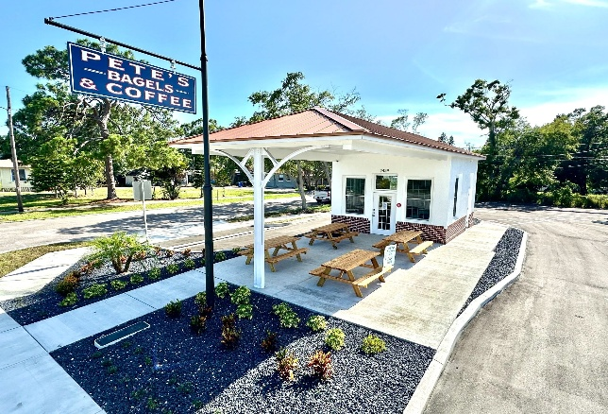
The rehabilitation of the 1926 Standard Oil Service Station in the St. Pete neighborhood of Harbordale is a model of community-driven preservation and adaptive reuse in St. Petersburg. In 2019, the deteriorated building, and lot filled with junked vehicles, stood as a blighted, highly visible eyesore along busy 4th Street South. Local resident and developer Robert Blackmon uncovered its history as a 1926 Standard Oil station and purchased the property to save it from demolition.

Guided by historic documentation, the project removed incompatible additions, reconstructed the original hipped roof, restored brickwork and installed new windows, returning the building to its 300 square foot footprint.

Through local landmark designation and the city’s adaptive reuse overlay, the station was transformed into a small drive-thru bagel and coffee shop, an economically sustainable use with reversible site changes. This project revived a forgotten landmark, strengthened neighborhood identity and turned a blighted corridor property into a community asset.

Chidsey Library
Sarasota, Sarasota County

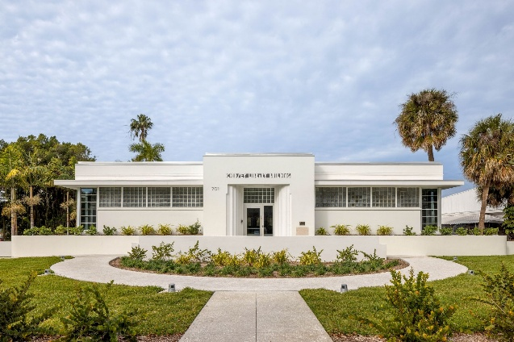
The rehabilitation and adaptive use of Sarasota’s historic Chidsey Library transformed a structurally failing and long closed landmark into an active civic asset while preserving one of Florida’s finest examples of Streamline Moderne public architecture. Constructed in 1941 as Sarasota’s first permanent public library and listed in 2011 on the National Register of Historic Places, the building faced potential demolition following decades of deterioration and structural instability. Through extensive structural stabilization and adherence to the Secretary of the Interior’s Standards, character-defining architectural features were preserved while the building was adapted and repurposed as the headquarters of The Bay Park Conservancy. Original terrazzo floors, glass block windows and library stacks were retained while modern systems ensured resilience, accessibility and flexibility of use. The project demonstrates how rehabilitation can extend civic legacy, avoid demolition and return historic buildings to meaningful public use.

Vizcaya Village
Miami, Miami-Dade County
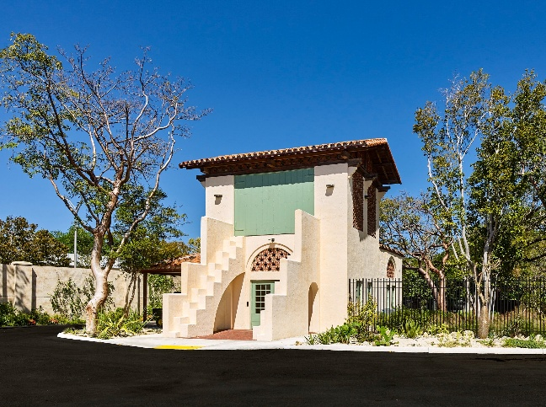
The Vizcaya Village project represents the first phase of a comprehensive master plan developed by M.C. Harry & Associates for Vizcaya Museum and Gardens and Miami-Dade County. The plan focuses on revitalizing the historic Farm and Village west of the Main House - an area that once housed the service buildings supporting the estate in the early 20th century but remained largely inaccessible to the public for decades. After periods of use by Miami-Dade Public Works and the former Museum of Science, the buildings returned to Vizcaya’s stewardship with a vision to transform them into spaces for education, exhibitions and museum operations.
Completed in 2024, Phase 1 restored four 1920s buildings—the Paint Shop, East Gate Lodge, Garage and Superintendent’s House—upgrading utilities and infrastructure while preserving their historic character. A non-contributing structure was removed to restore the landscape and create agricultural and parking areas. Today, Vizcaya Village serves as a welcoming community space featuring educational programming and a weekly farmers market.

Boca Chita Lighthouse
Biscayne Bay, Miami-Dade County

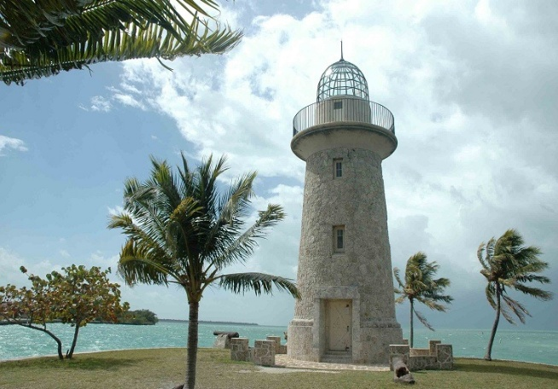
The iconic and historic Boca Chita Lighthouse, built by Mark Honeywell in the 1930s, guides boats to the beauty and wonders of Biscayne National Park. The observation deck of the 60-foot-tall lighthouse provides a panoramic view of islands, bay, ocean and Miami skyline. The once-private 32-acre island of Boca Chita Key is the most visited island in the park, and the Boca Chita Lighthouse is a significant draw for locals and tourists, and is a contributing structure within the Boca Chita Key Historic District.

Featuring a tapered 65-foot beacon built from native coral rock, the interior stair was designed to imitate medieval stone masonry. The scope of work included repairs to the iconic coral stone plaza mortar, the masonry tower walls required replacement of corroded reinforcing bars with stainless steel, injection grouting and repairs to the coral stone fillet walls. Other work included replacing the corroded chain outside the lighthouse, as well as repairs to the damaged moldings, surrounds and corroded metals on the windows and doors of the lighthouse.

Freedom Tower
Miami, Miami-Dade County
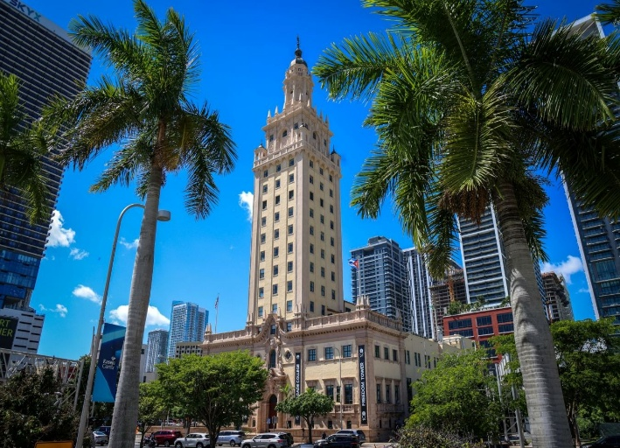
The Freedom Tower is considered the Ellis Island of the South for its role during a twelve year period between 1962 and 1974 as the Cuban Assistance Center, offering nationally sanctioned relief to Cuban refugees who sought political asylum from the Communist regime of Fidel Castro. Architect of Record M.C. Harry & Associates, worked in close partnership with Historic Preservation architect, R.J. Heisenbottle Architects who has been involved with the project since the original restoration work of 1987.

The exterior scope of work included exterior masonry conservation and stabilization of historic cast stone on the richly articulated façades, complex copper roof repairs that restored the integrity and weather performance of the building’s distinctive dome and ornamental weathervane and exterior painting that matched the historic color palette. Interior work included recreation of the historic Spanish ceramic tile flooring, historic replication of the lobby chandelier, treatment of the monumental New World 1513 mural, restoration of the historic lobby stone flooring and walls, conservation of the original wood lobby doors and brass railings and the application of a faux travertine plaster finish on the Freedom Hall columns. Each intervention was executed in accordance with the Secretary of the Interior’s Standards and was supported by extensive archival research, paint analysis, and field verification to ensure material compatibility and long-term performance.

Organizational Excellence
This award acknowledges excellence in historic preservation by a group, corporation,
neighborhood or other organizations.

Opa-locka Heritage Trail & Opa-locka Museum of History & Art
Opa-locka, Miami-Dade County
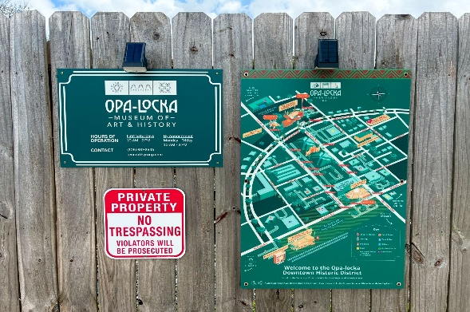
Ten North Group has played a leading role in revitalizing historic preservation in the City of Opa-locka, one of Miami-Dade County’s oldest municipalities and home to one of the nation’s largest collections of Moorish Revival architecture. Building on preservation efforts first championed in the 1980s, the organization partnered with the City and community stakeholders to reawaken a commitment to safeguarding Opa-locka’s unique heritage. In 2024, Ten North Group helped bring to life the Opa-locka Heritage Trail, a 15-station interpretive walking experience highlighting the city’s historic landmarks and founding story. Complementing the Trail is the Opa-locka Museum of Art & History, housed in the restored 1927 Seaboard Air Line Railroad Station, which now serves as the city’s central exhibition space dedicated to its cultural and architectural legacy.
Together, these initiatives preserve Opa-locka’s past while inspiring renewed pride, investment and community engagement as the city approaches its centennial in 2026.
GFWC Coco Plum Woman’s Club
Coral Gables, Miami-Dade County
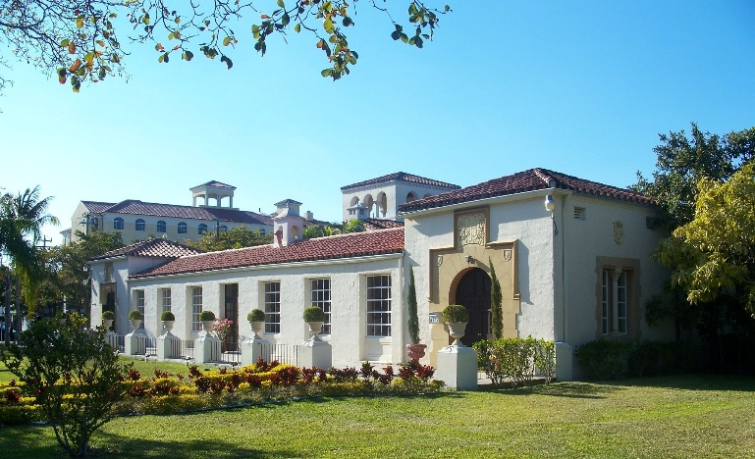
Founded in 1912, GFWC Coco Plum Woman’s Club has long stood as a cherished part of Coral Gables’ civic and cultural life. What began as a small gathering of eight visionary women grew into a vibrant organization devoted to service, fellowship and community betterment. For more than a century, the Club has carried forward a proud legacy of philanthropy and civic engagement, while its historic clubhouse remains a beloved landmark and enduring symbol of its remarkable history. The pioneer women that came from urban areas left a legacy of continuing contributions of cultural improvements into community service, which has been proudly received by the succeeding members of the Coco Plum Woman’s Club and carefully preserved through the years.
Stewardship is a core value and this commitment to exemplary maintenance is highlighted by the Club’s allocation of 20% of all Club fundraisers and rentals to the Maintenance and Restoration Fund. The Club retains an in-house maintenance staff to keep the building in optimum condition. Coco Plum Woman’s Club is committed to maintaining the history of the building and providing a legacy for future generations.
Historic buildings like this Clubhouse are living history serving as living classrooms where future generations will be able to study history, architectural craftsmanship and social progression.

Conservation, Preservation, Maintenance and Repair
This newest award category rewards best practices applied to the preservation of historic resources. Proper maintenance is an under-celebrated but critical aspect, and this award celebrates thoughtful and creative approaches for projects that conserve historic materials. This award is for projects of limited scope that meet the Secretary of the Interior’s Standards for the Treatment of Historic Properties for “Preservation,” and include measures to protect and stabilize the property and address the ongoing maintenance and repair of historic materials and features.

Zion Missionary Baptist Church
St. Augustine, St. Johns County
(Preservation)

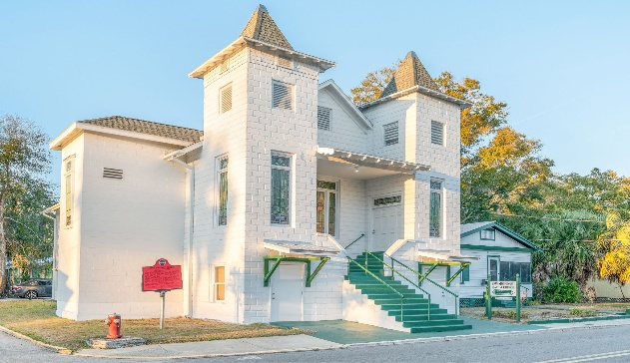
Established in 1886, Zion Missionary Baptist Church is the oldest African American congregation in West Augustine and a vital landmark in St. Augustine’s cultural and civil rights history. Originally founded so members could worship closer to home rather than walk to Lincolnville, the congregation built its enduring two-story coquina concrete block sanctuary in 1921. During the Civil Rights Movement, the church served as a gathering place for organizing and public addresses that helped bring national attention to St. Augustine’s struggle for equality. Sarah Ryan Architect, LLC led the restoration of this more than century-old structure, addressing significant structural deterioration while preserving its historic character. The project stabilized bowed masonry walls, rebuilt the historic steeple, restored stained-glass windows and original wood elements and repaired the roof and foundation systems to protect the building for future generations.

Through close collaboration with the congregation and local craftspeople, the restoration returned Zion Church to active community use, preserving an authentic part of St. Augustine’s heritage.

St. James AME Church
Sanford, Seminole County
(Preservation)

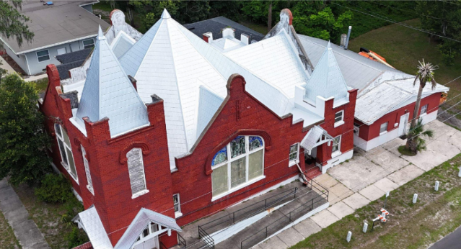
The St. James AME Church metal reroof project reflects the power of partnership, preservation and community commitment. Completed in close collaboration with the City of Sanford, the project focused on protecting a historic and deeply valued place of worship while ensuring long-term durability and resilience. Careful coordination allowed church services and community activities to continue with minimal disruption, while structural improvements and a modern metal roofing system delivered lasting performance and storm resistance suited to Florida’s climate.

More than a construction project, this effort helped preserve an important cultural landmark and reinforced community pride. The partnership between the City, the church, and the project team of Evans Roofing demonstrates how thoughtful planning and collaboration can protect history, serve people, and create lasting value. The St. James AME Church reroof stands as a meaningful investment in Sanford’s heritage and future.
St. Philip’s Episcopal Church
Jacksonville, Duval County
(Preservation)
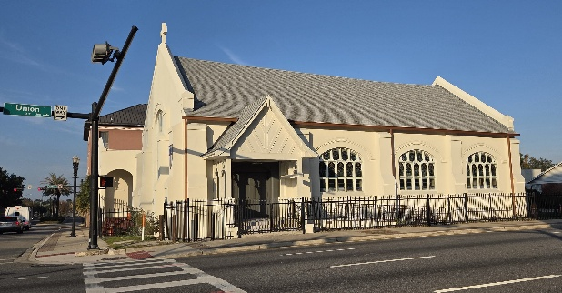
Established as the city’s first African American Episcopalian church, and the second in the state of Florida, St. Philip’s 1906 Gothic Revival sanctuary required new exterior stucco, renovation of the stained-glass windows with protective coverings, wood rot repair and a new drainage system. The exterior renovation of St. Philip’s was a multi-year, multi-grant funded project recently completed in the heart of downtown Jacksonville. The project is a successful renovation of a landmarked building built by parishioners from the ashes of the Great Fire of 1901 as designed by the first licensed female architect in Florida. The project is also a testament to restoring a rare remnant of the former African American Hansontown community.

155 Cordova Street, DeMedici House
St. Augustine, St. Johns County
(Preservation)

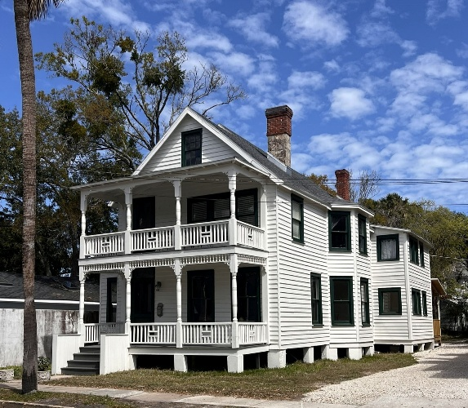
The DeMedici House, located at 155 Cordova Street, a home constructed between 1865 and 1884 and had been converted into multi-family units over time. In 2022, current owner Gabriel “Gabe” Wicks brought his passion and years of experience in historic restoration and rehabilitation from Tennessee to St. Augustine, purchasing this property sight unseen with the goal of rehabbing the structure and returning it to a single-family home. Wicks dove into the history of the property, finding historic photos of the front porch which he used as a template to restore original porch features. He enlisted the help of skilled contractors but also performed work himself, including window restoration. The result is a praiseworthy preservation project that combines restoration of existing and once lost architectural features with the addition of compatible new features to the historic structure, adding value and livability while enhancing the historic integrity of the contributing property and the streetscape of the St. Augustine National Historic District.

Coconut Grove Schoolhouse
Miami, Miami-Dade County
(Repairs)

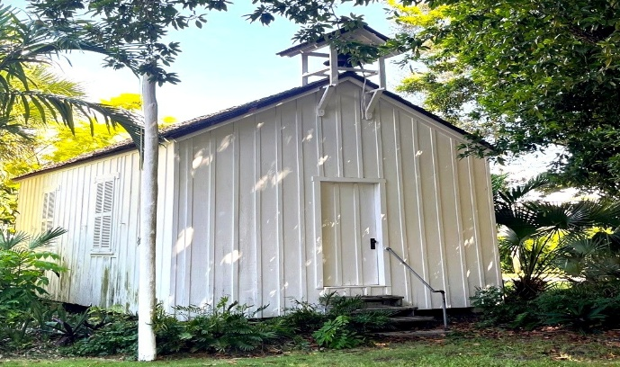
The oldest schoolhouse in Miami, built in 1897, was restored in 2025 by Plymouth Congregational Church. The school sits on the grounds of Plymouth’s campus and stands as a tribute to early pioneer life in Coconut Grove.

The repair work included replacing deteriorated boards, repairing the bell tower and making other needed repairs. Funding for the project was provided in large part by a grant from The Villagers preservation organization and a private donation. The schoolhouse was central to early settlers' religious, education and social activities. It is among the community's oldest buildings and is a notable example of late nineteenth-century vernacular architecture. It served as a public school until 1894, when a larger school was constructed.

In 1969, James Ryder, a member of Plymouth Congregational Church and founder pf Ryder Systems, restored and donated the schoolhouse to Plymouth, relocating it to the church campus. On January 21, 1975, it was added to the National Register of Historic Places.

GFWC Coco Plum Woman’s Club
Coral Gables, Miami-Dade County
(Maintenance)

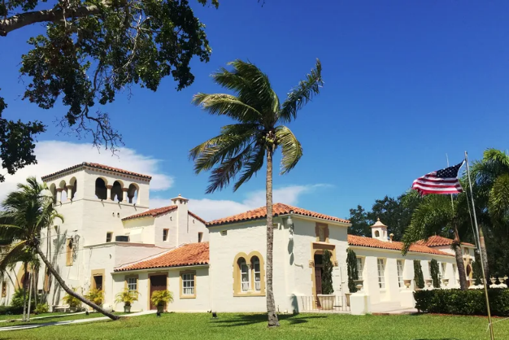
For more than a century, the GFWC Coco Plum Woman’s Club has carried forward a proud legacy of philanthropy and civic engagement, while its historic clubhouse remains a beloved landmark and enduring symbol of its remarkable history. Maintaining the historically designated style of Mediterranean Revival, GFWC Coco Plum Woman’s Club works hard to balance the needs to modernize the building without impacting its historical character.

The organization’s commitment to a comprehensive and consistent maintenance program is exhibited through a recent project. The electrical system work included a complete update of all wiring and electrical components, and conservation and repairs to the historic lighting, in order to meet current code requirements while retaining the historical integrity of the interior spaces.

The Rotunda at Collins Park
Miami, Miami-Dade County
(Conservation)

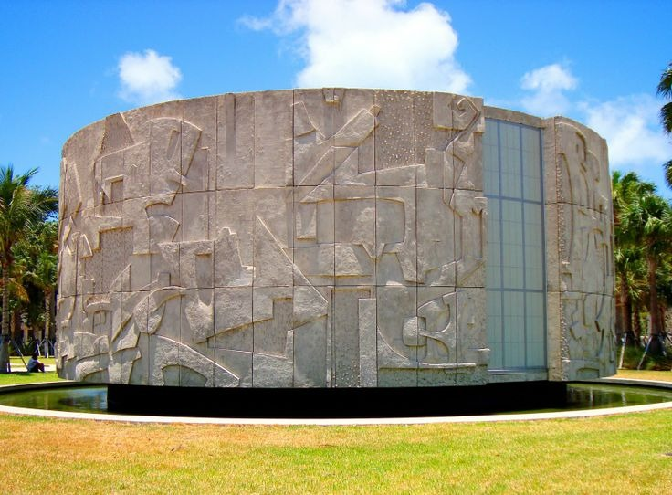
The Rotunda at Collins Park remains the last element of Miami Beach’s original 1961 public library complex and is fully encircled by 164 monumental sand-cast sculptural panels by artist Albert Vrana. After more than sixty years in a harsh coastal environment, hidden corrosion and structural deterioration were discovered behind the mural façade during a 2024 renovation. Rather than accept partial or cosmetic repairs, the City of Miami Beach authorized a comprehensive conservation scope to safely remove, treat and reinstall every panel. VAS Art Productions engineered a custom handling system and conservation approach that protected fragile sculptural edges while upgrading anchors, stabilizing concrete and preserving Vrana’s sand-cast texture. Completed in December 2025, the project secures an irreplaceable work of integrated public art and ensures that the Rotunda can continue to serve as a civic landmark while remaining materially authentic to its mid-century origins.

Wauchula City Hall
Wauchula, Hardee County
(Preservation)

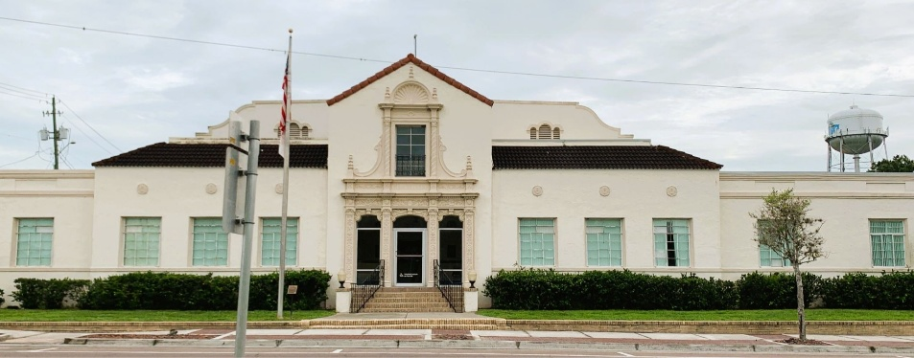
Constructed in 1926, Wauchula City Hall stands as one of the most important civic landmarks in Hardee County. Designed by architect M. Leo Elliot, the Spanish-influenced building once housed city offices, a fire station and a large public auditorium that served as the region’s primary cultural venue. Located within the Downtown Wauchula Historic District, the building reflects the early twentieth century development of Wauchula as the governmental and economic center of Hardee County.

The preservation project focused on preserving the building’s historic steel windows, which had deteriorated due to corrosion and failing glazing systems after nearly a century of exposure to Florida’s climate. Rather than replacing the windows, Austin Historical carefully restored the original window systems, stabilizing steel components, repairing frames and reglazing historic openings. The project preserved a defining architectural feature of the building while ensuring the continued use of this important civic landmark within Wauchula’s Historic District.

Ybor Square Historic District: The Church of Scientology of Tampa
Tampa, Hillsborough County
(Preservation)

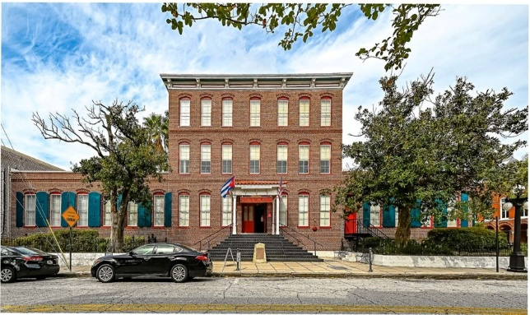
Situated in the heart of Tampa’s historic Ybor City, the Church of Scientology Tampa occupies the Ybor Square complex, one of the most historically significant industrial sites in Florida. Completed in 2025, the project involved the restoration of 319 historic windows, 628 sash and more than 3,000 glass lites across the Factory, Stemmery and Lookout buildings. Austin Historical carefully restored the original window systems in accordance with the Secretary of the Interior’s Standards, preserving historic materials while fabricating replacement components using traditional mortise-and-tenon joinery. 212 custom storm windows were also installed to protect the restored windows and improve building performance. The project preserves one of Ybor City’s most recognizable landmarks while ensuring that the historic complex continues to serve the community for generations to come.

Caples Mansion Estate
Sarasota, Sarasota County
(Preservation)

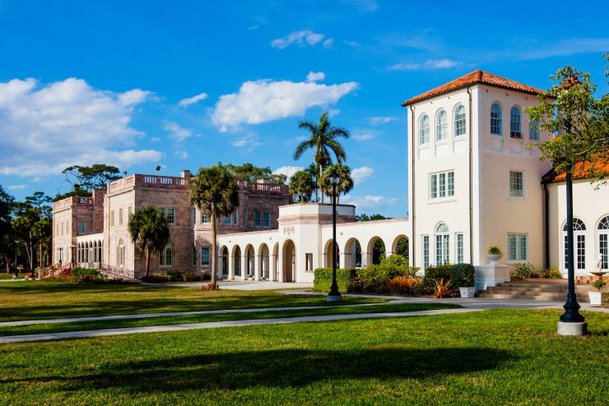
Caples Mansion, constructed in 1925 along Sarasota Bay, is one of the most historically significant residences within the New College of Florida campus and part of the New College Historic District listed on the National Register of Historic Places. Built as the winter estate of industrialist Charles Caples, the Mediterranean Revival mansion reflects the architectural character of Sarasota’s early development during the 1920s land boom. A former 2017 11 to Save success story, the preservation project focused on preserving the building’s historic windows, doors and screen systems, which had deteriorated after nearly a century of exposure to Florida’s coastal climate. Austin Historical restored 65 historic wood windows, 107 sash and 363 glass lites, along with 26 historic doors and 8 screen doors, using traditional preservation techniques. Original materials were retained whenever possible, and replacement components were fabricated to match historic profiles and joinery. The project preserves a defining architectural feature of the mansion while ensuring the continued use of this important historic residence within the New College campus.

Burrows-Matson Residence at Bay Preserve at Osprey
Osprey, Sarasota County
(Preservation)

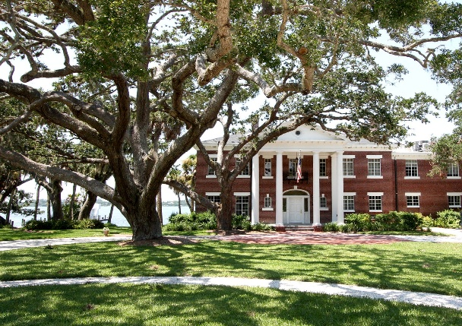
The Burrows-Matson Historic District at Bay Preserve represents one of Sarasota County’s most significant historic waterfront estates. Constructed beginning in 1931 and later stewarded by the Sarasota Conservation Foundation (now known as Big Waters Land Trust), the property contains a collection of architecturally significant structures overlooking Little Sarasota Bay. Austin Historical completed the restoration of the Burrows–Matson Residence’s historic steel casement windows and wood doors - character defining elements of the Neoclassical Revival building. A total of 118 steel casement windows were carefully restored using traditional preservation techniques, including rust treatment, repair of damaged steel members, restoration of original hardware and installation of annealed glass set in traditional linseed oil putty. Wood windows and exterior doors were similarly conserved through epoxy consolidation, Dutchman repairs and historically appropriate finishes. The project preserved the architectural integrity and operability of these original elements while extending their service life for generations.

Terrace Hotel
Lakeland, Polk County
(Preservation)

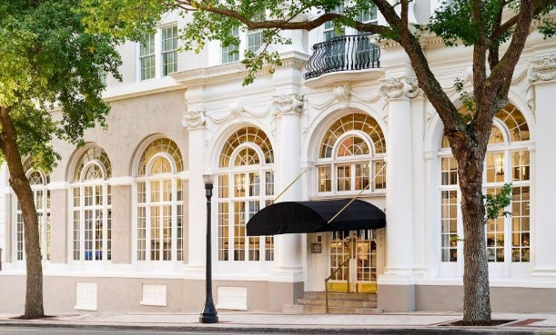
Constructed in 1924, the Terrace Hotel is one of Lakeland’s most prominent historic landmarks and a defining feature of the city’s downtown historic district. The preservation project focused on preserving the monumental arched window and door openings that characterize the hotel’s lobby, dining and lounge spaces. Austin Historical restored 12 historic window openings containing 27 sash and 304 individual glass lites, many measuring more than 15 feet in height. Custom replica arched sash and transoms were fabricated using traditional mortise-and-tenon joinery and 46 replica doors were constructed to match the original divided light configurations. Historic jambs and surrounding trim were repaired and refinished to restore the architectural character of the façade. By preserving these dramatic openings rather than replacing them with modern systems, the project maintains the historic integrity of one of Lakeland’s most recognizable buildings while ensuring the long-term durability of these character defining architectural elements.

###

About the Florida Trust

The Florida Trust for Historic Preservation is the state’s nonprofit dedicated to protecting Florida’s extraordinary heritage and history. Founded in 1978, the Florida Trust has collaborated to save irreplaceable Florida treasures like the Historic Florida Capitol and is a statewide partner of the National Trust for Historic Preservation. Learn more at FloridaTrust.org

